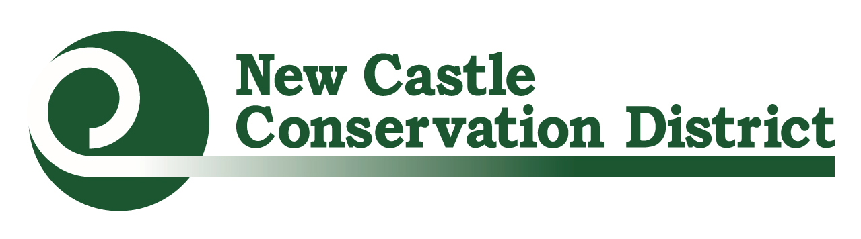Urban Farmer & Gardener Mini-Grants Application
Directions: Place cursor in blue box to complete information. Click “Tab” to proceed to next form field.

I. Organization Information:
Organization Name: Tax ID EIN:
Address: City: State: ……….... .Zip:
Contact Person: Title:
Phone: Email:
Secondary Contact Person (if applicable):
Phone: Email:
Website (if applicable):

Total Project Budget: Amount Requested (up to $3,000):
Location of Project:

One to two sentence summary of the project to be funded:

II. Project Information
Is this a ☐existing or ☐ new project?
Describe the project to be funded, including relevant project background/history, the community being served, how the grant funds will be used, and the significance (impact) the grant project will have on the local community.

How will this project improve access and/or the production of local, healthy foods throughout underserved areas in NCCo?

List 1-2 goals for the project. These goals should be the overarching changes that you would like to see as a result of this project and should be realistic based on the project’s scale.
Ex. Improve access to fresh vegetables to community members living in the Mr. Rodger’s Neighborhood.

List 2-3 objectives per goal for the project. Objectives should be the tangible results of your project and should help paint a picture of what project success would look like.
Ex. Every month, from May to September, the 8th Street Community Garden leadership committee will host a workshop as part of our soil to table education series for at least 10 community members.
Ex. Build 4 additional raised beds in the community garden to grow crops for use in our food pantry during the upcoming summer season.

III. Project Sustainability
What is relevant experience of the individuals involved? If limited what is your action plan to learn more?

How do you plan to sustain this project over time? If buying equipment or supplies for an existing project, how will these funds help to sustain your farm or garden over time?

What will you do to engage your community in the project, such as youth, families, employees, neighbors, and local businesses?

List all organizations (stores, other non-profits, schools, garden clubs, etc.) in the community that have previously contributed to your project.
Organization Name | Contact Person | Contribution Type (monetary, in-kind, donation) | Details/Further Information
Ex. Green Thumbs | Joe Green  jgreen@gmail.com | Donation | Garden Gloves and Transplants
Ex. Star Church | Mae Rose  volunteers@starchurch.com | In-Kind | Volunteer Hours during garden cleanup event

IV. Required Attachments
☐ Letter of Support: Application must be submitted with a letter from the organization’s leader committing support to the project. Official letterhead and physical signature must be present.
**If the project is to be completed on property not owned or leased by the applying organization an additional letter of support must be submitted by the property’s controlling agent**
☐Budget:
1. Annual budget for the project, including a general list of expenses and costs
2. Detailed expenses that you plan to use the NCCD mini-grant to cover and required match (see example in the Request for Proposal)
This is a reimbursement grant, and advances are not available. Invoices and itemized receipts must be submitted for reimbursement as per the approved financial agreement.
☐Project Photos: Email no more than 3 photos of your site to Madison.Walter@delaware.gov. Please note the following requirements:
- Save images as .jpg or .png files
- New projects should provide existing space photos
- Any photos with people in them must have a photo release form signed

V. Sign and Submit Application
Applications must be received by 4:30pm March 7th, 2024. They may either be emailed to Madison.walter@delaware.gov or they can be hand delivered/sent to:
New Castle Conservation District
Urban Farmer & Gardener Mini-Grant
2430 Old County Road
Newark, DE 19702

Please sign and date in the spaces provided below

Print Name

Sign Name

Date

